EPABX Lines Screen
  - Purpose
    - This screen manages the information of different EPABX lines.
    - It will contain the information about the EPAPX lines in Dera only.
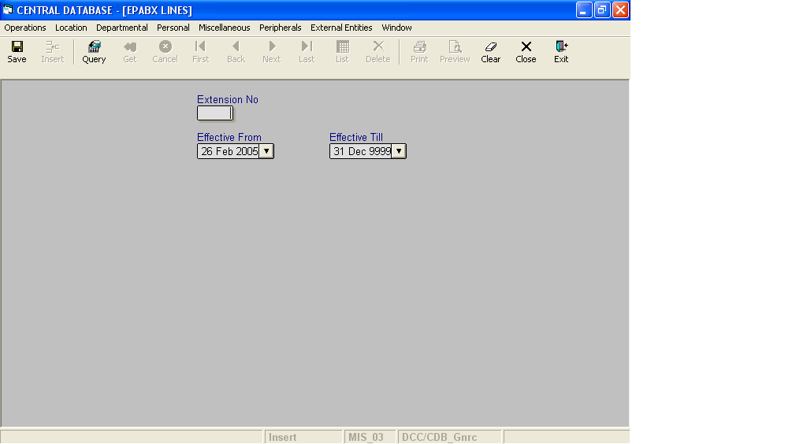

Layout as seen on opening of the Screen
  - Events associated
None
  - Modes
    - It will start in Insert mode.
    - It supports Insert, Query, Retrieve, Browse, List, New, Update and Reference modes.
  - Field specifications

 | Type | Length | Optional | Insert Mode | Query Mode | BrowseMode
Extension No | extension_no | 5 | N | Allow | Allow | Allow
Effective From | datetime | 8 | N | Allow | Allow | Allow
Effective Till | datetime | 8 | N | Allow | Allow | Allow
  - Fields
    - Extension No
      - This is the extension number which uniquely identifies all the EPABX Lines.
    - Effective From
      - This is the date since which an EPABX Line is effective.
      - By default, the system will display the current date in Insert Mode.
      - Normally, it should not be a future date. This is the recommendation. System will display a warning, if future date is specified.
      - It cannot be later than the date specified in Effective Till.
    - Effective Till
      - This is the date till which an EPABX Line is effective.
      - By default, the system will display 31-Dec-9999 in Insert Mode.
      - Normally, it should not be a past date.
      - It cannot be earlier than the date specified in Effective From.

  - Action Buttons
None
  - Users / User Roles
CDB_Gnrc user is permitted to insert, update, delete and select EPABX line.
  - Other Considerations
None

